Installing Adobe X STD and Acrobat Reader together in Windows 7 Virtual Desktop

Customizing Adobe Acrobat X Standard installation

Download and install Adobe Customization Wizard X

Copy the setup files to a working directory (eg: D:\WorkDir\AcrobatXStd-Install)

Run Adobe Customization Wizard X and open the msi file from D:\WorkDir\AcrobatXStd-Install

Set the following settings

Personalization Options:
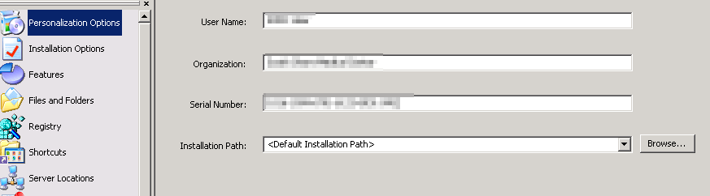

Installation Options:
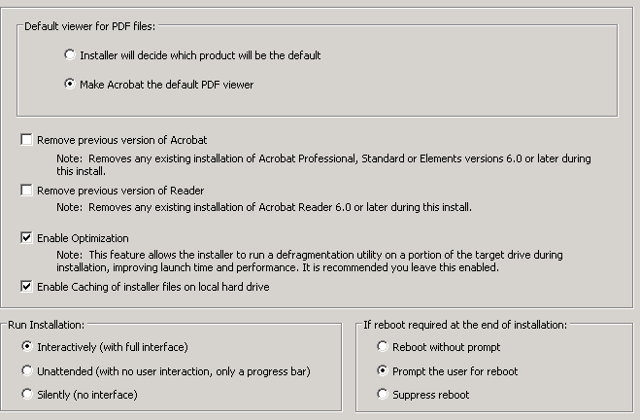

Features:
Disable the ones that not required for your environment, (eg: Lotus Notes and Mozilla integration is suppressed)
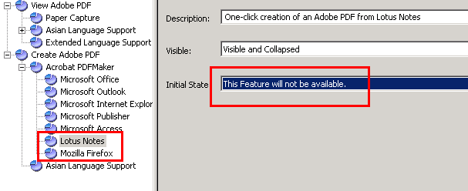

Files and Folders:
Copy HideMenu.js to JavaScript’s directory
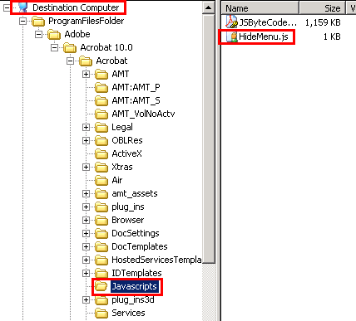

Registry:
Create/Set the following Values
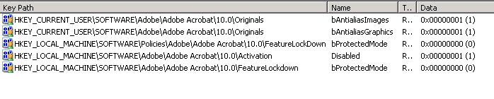

Shorcuts:
Suppress creation of Icon on the Desktop

EULA:
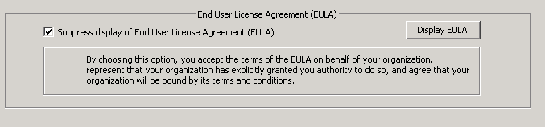

Online and Acrobat.com Features:
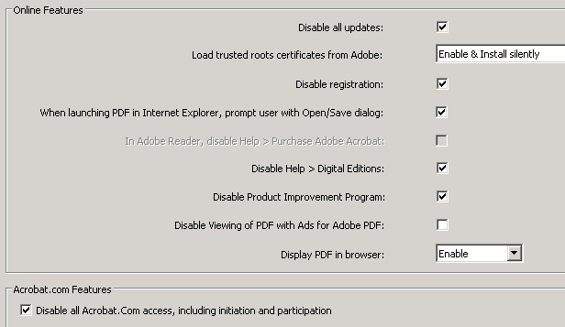

Set any other settings unique to your environment like rights management servers, Digital Signatures etc.

Save Package will generate an mst file which holds all these settings.

Customizing Adobe Reader X Installation

Get latest Adobe Reader Installation from http://get.adobe.com/reader/otherversions/

Extract the exe using achieve tools like 7-zip to working directory (eg: D:\WorkDir\AcrobatXRdr-Install)

Run Adobe Customization Wizard X and open the msi file from D:\WorkDir\AcrobatXRdr-Install

Set the following settings

Files and Folders:
HideMenu.js is the same file that was used for Adobe Acrobat X Standard
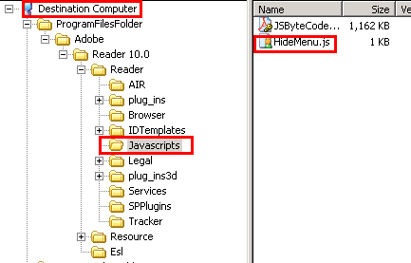

Registry:

Shortcuts:
Suppress all

EULA:

Online and Acrobat.com Features:
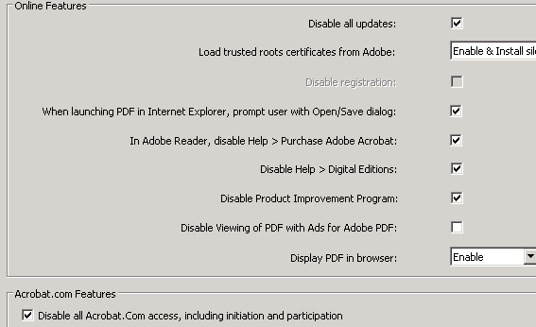

Set any other settings unique to your environment like rights Security, Digital Signatures etc.

Save Package will generate an mst file which holds all these settings.

Performing the customized Adobe Acrobat X Standard Install

Performing the customized Adobe Reader X Install

Changing the Adobe PDF Printer Security permission
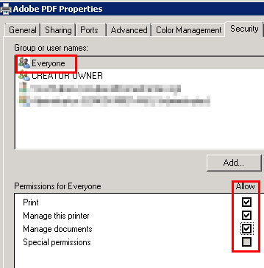

Changing the Registry permission for Office Adobe Add-Ins

Set everyone full permissions for the followings keys
HKLM\SOFTWARE\Microsoft\Office\Word\Addins\PDFMaker.OfficeAddin
HKLM\SOFTWARE\Microsoft\Office\Access\Addins\PDFMaker.OfficeAddin
HKLM\SOFTWARE\Microsoft\Office\Excel\Addins\PDFMaker.OfficeAddin
HKLM\SOFTWARE\Microsoft\Office\Outlook\Addins\PDFMOutlook.PDFMOutlook
HKLM\SOFTWARE\Microsoft\Office\Powerpoint\Addins\PDFMaker.OfficeAddin
HKLM\SOFTWARE\Microsoft\Office\Publisher\Addins\PDFMaker.OfficeAddin

Restrict Acrobat X Std access to certain User Group using App-Locker

Enable Applocker and set an exception for Program Files Folder
Exception path being C:\Program Files\Adobe\Acrobat 10.0\*

Create a new rule with that path and provide access to a user group. (eg: Applocker-AcrobatStdXUsers)

Change the file type associations and explorer content menu options using login script (powershell)
Snippet for login script
#Acrobat PDF
if(($objUser.memberOf -contains "CN=AppLocker-AcrobatXStandard,OU=Microsoft,OU=Infrastructure,OU=Servers,DC=mulpuru,DC=local"))
{
REG IMPORT "C:\domain\Packages\Adobe\AcrobatEditorFileAssoc.reg"

}

else
{
$PrintAcrobatPrinterObj = Get-WMIObject -query "Select * From Win32_Printer Where Name = 'Adobe PDF'"
$PrintAcrobatPrinterObj.delete()
REG IMPORT "C:\domain\Packages\Adobe\AcrobatReaderFileAssoc.reg"
}

